More about mixed numbers

Exercise 1:
This exercise is to be completed without a calculator.
Convert the improper fractions into mixed numbers and write in order of size, smallest to largest:
, , , , = , = ,, = ,.

…......................................................................................................................................................................

Exercise 2 :
This exercise is to be completed without a calculator.
Work out these calculations. Give your answer as a mixed number.
a. = ….............................................................................................................................................
b. = ….............................................................................................................................................
c. = ….............................................................................................................................................
d. = ….............................................................................................................................................

Exercise 4 :
In Great Britain, pupils learn how to calculate with proper fractions, improper fractions and mixed numbers. They often have to give their answer as a mixed number.
In France, pupils learn how to calculate with fractions (proper and improper). They often have to give their answer as a fraction in its simplest form.
Is it easier to use mixed numbers or improper fractions when you :

compare numbers: …......................................................................................................................................

add or subtract numbers: ….............................................................................................................................

multiply or divide numbers: …........................................................................................................................

Exercise 5 :
Put these fractions in order from the smallest to the largest.
, , , ,
….....................................................................................................................................................................
….....................................................................................................................................................................
….....................................................................................................................................................................
….....................................................................................................................................................................
….....................................................................................................................................................................
….....................................................................................................................................................................

Card trick with fractions :
- Watch the video : http://www.tes.co.uk/teaching-resource/Fractions-Using-Reciprocals-6085222/
- Did you get how he did it? Explain his method.

.............................................................................................................................................................
.............................................................................................................................................................
.............................................................................................................................................................
.............................................................................................................................................................
.............................................................................................................................................................
- Put the following fractions in order using the same method: , , , , .
.............................................................................................................................................................
.............................................................................................................................................................
.............................................................................................................................................................
.............................................................................................................................................................
Crossword puzzle :
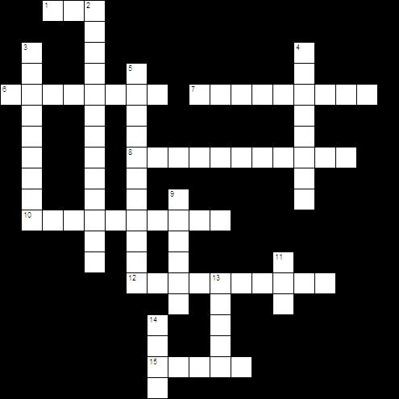
Across  1 largest factor that two numbers have in common  6 _____ fractions - the numerator is larger than the denominator  7 tells how many equal parts are used, shaded, etc.  8 common denominators are not required when ____ 2 fractions  10 fractions that have the same value  12 the product of a number and its ____ equals one  15 whole number with a proper fraction is called a ____ number | Down  2 prime _____ is when prime numbers are multiplied together to get the original number  3 a whole number with more than two factors  4 part / whole  5 tells how many equal parts make one whole  9 to change a fraction to its lowest terms  11 is useful in finding the least common denominator when adding unlike denominators  13 a whole number greater than 1 with only two factors  14 when adding fractions the denominators must be the ____.

