Shapes and shape words

Name: _____________________________

Form: _____

Maths teacher: _____

Answers:

acute angle
arc
base
centre UK / center US
chord
circle
circumference
cone
cube
cuboid
cylinder
diagonal
diameter
edge
equilateral triangle
face
hexagon
irregular polygon
isosceles triangle
kite
net
obtuse angle
octagon
parallelogram

pentagon
plane
polygon
prism
pyramid
quadrilateral
radius
rectangle
reflex angle
regular polygon
rhombus
right angle
right-angled triangle
scalene triangle
side
sphere
square
straight angle
tangent
trapezium UK/ trapezoid US
triangle
vertex
vertices

Circles

r __________

O

d__________

O is the c___________ of the c____________

a_________

c___________

t ____________

The distance around the circle is the c_______________
Polygons

A p_____________ is any 2D shape with straight sides.
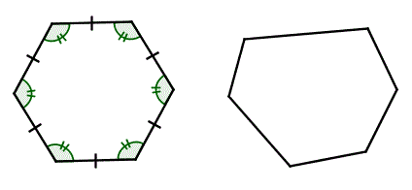

v__________

v______
d__________ s___________

If all the sides and angles are the same, it is a r_______________ p_____________. | If they are not all the same, it is an i________________ p_____________.

Number of sides | Name of polygon
3 | t________________
4 | q_______________
5 | p_______________
6 | h_______________
8 | o_______________
Triangles

All sides and angles equal:

e _______________

Two sides and angles equal:

i _______________

All sides different:

s ____________

r _____________ and s____________ triangle

r_____________________

r ______________ and i__________ triangle

Quadrilaterals

s_________ r_____________

p_______________ k_______

t_______________

r__________

q______________

Angles

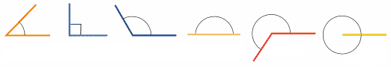
a__________ r__________ o__________
__________ __________ __________
less than ____° exactly ____° greater than ____°
and less than ___°

s__________ r__________
a__________ a__________
exactly ____° greater than ____°

3D shapes

c_______ c__________

c_________ c_______

s_________
Other words
v____________

v___________

e______ f________

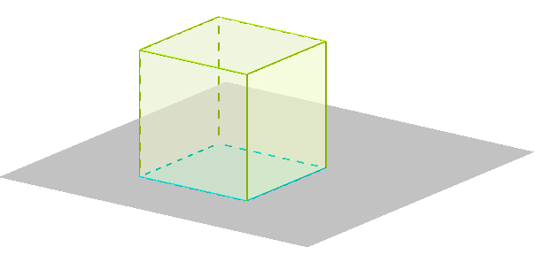

n______

p________

Prisms or pyramids?
acute angle angle aigu
b_______
arc arc
base base
centre UK / center US centre
chord corde
circle cercle
circumference circonférence
cone cône
cube cube
cuboid pavé droit ou parallélépipède rectangle
cylinder cylindre
diagonal diagonale
diameter diamètre
edge arête
equilateral triangle triangle équilatéral
face face
hexagon hexagone
irregular polygon polygone irrégulier
isosceles triangle triangle isocèle
kite n'a pas de nom, parfois cerf-volant
net patron
obtuse angle angle obtus
octagon octogone
parallelogram parallélogramme

pentagon pentagone
plane plan
polygon polygone
prism prisme
pyramid pyramide
quadrilateral quadrilatère
radius rayon
rectangle rectangle
reflex angle angle rentrant
regular polygon polygone régulier
rhombus losange
right angle angle droit
right-angled triangle triangle rectangle
scalene triangle triangle quelconque
side côté
sphere sphère
square carré
straight angle angle plat
tangent tangente
trapezium UK/ trapezoid US trapèze
triangle triangle
vertex sommet
vertices sommets

