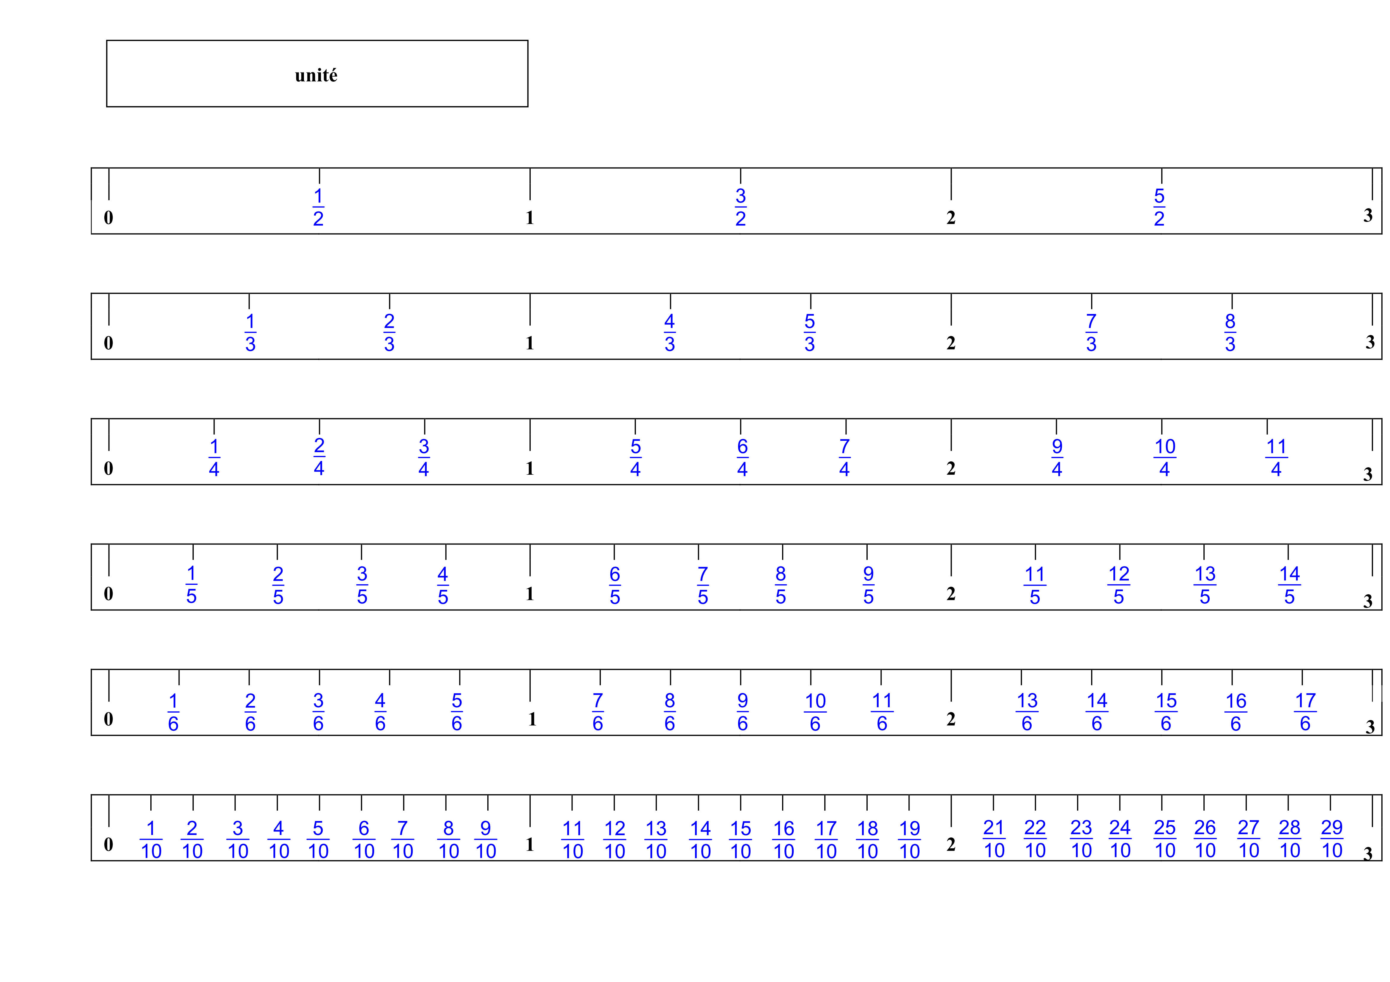
0
1
M
0
1
P
R
Q
T
S

