Installing PyCharm
Beside of using Scratch and other tools in our WorkShop, we’ll start using a real programming language called Python . Gladly, PyCharm is free and it’s available for Windows, Mac Os and Linux distributions. Also it provides a bunch of tools to perform scientific computation as well.

The first thing to do is to access the site of PyCharm. Click on download and chose the platform you wish:
Chose the Free version of the program. It will allow you to have all you need to start developing some nice pieces of software.

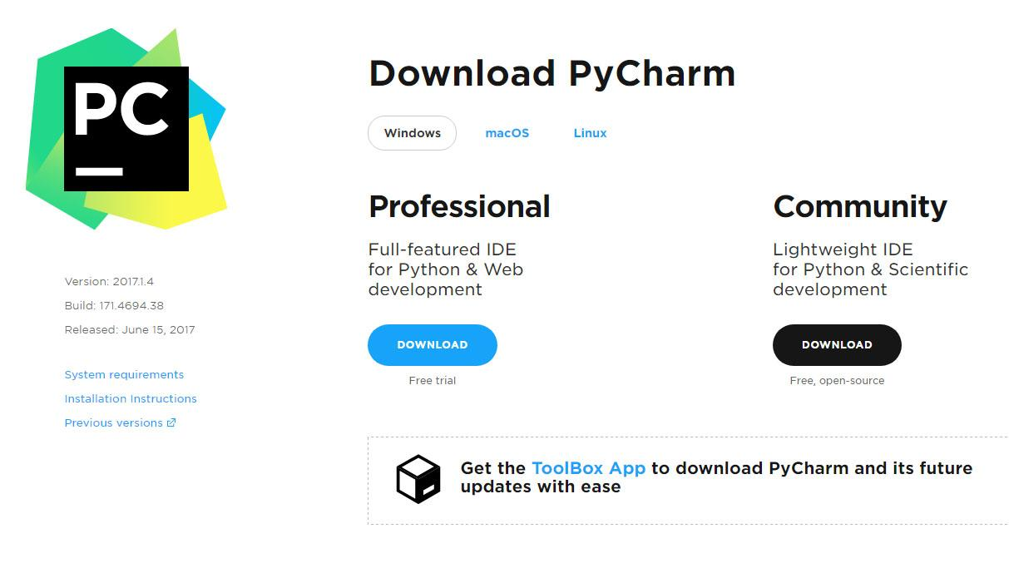

Windows
Download

After installing, you can open PyCharm.
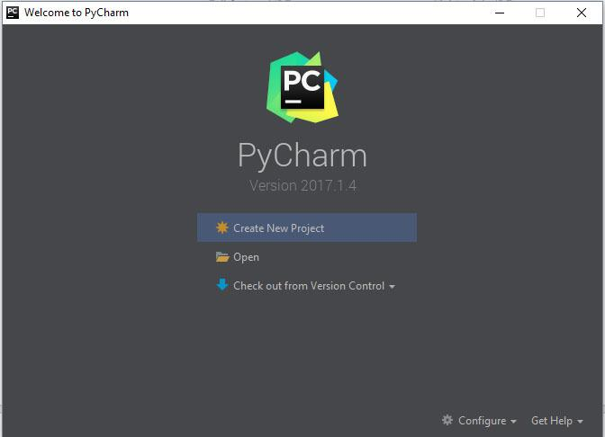

Click on “Create New Project”
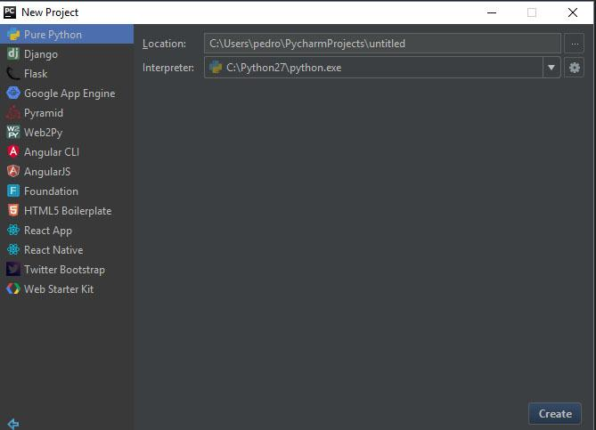

Select “Pure Python” and also change the location where you want to save your project. Notice that on the “Interpreter” field, you must direct the path where Python is installed. To verify if you have Python installed in your computer, the command line tool…

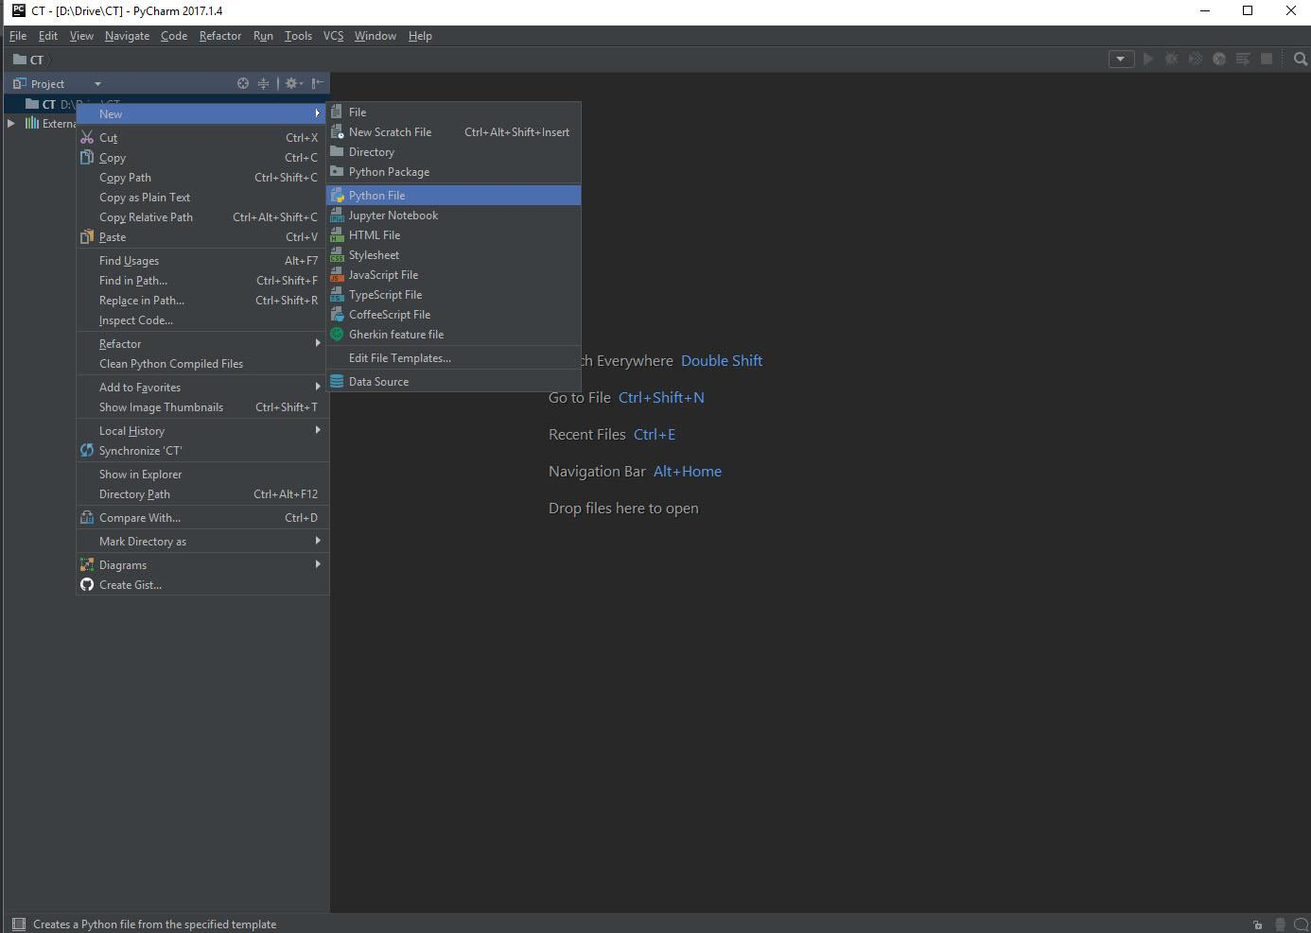

Create a new Python File as the picture above.

Mac Os
Download

Linux
Download

